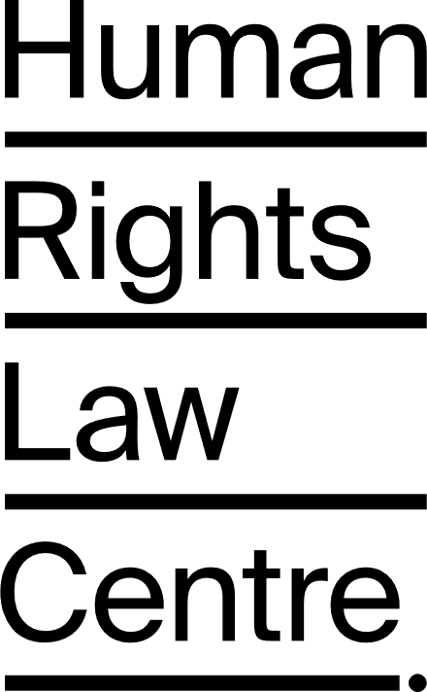

  - Submission to 2023-24 Federal Budget consultation
27 January 2023 / Daney Faddoul

Daney Faddoul
Campaign Manager
Human Rights Law Centre Ltd
Level 17, 461 Bourke Street
Melbourne VIC 3000
T: + 61 3 8636 4450
F: + 61 3 8636 4455
E: daney.faddoul@hrlc.org.au
W: www.hrlc.org.au
Human Rights Law Centre
The Human Rights Law Centre uses strategic legal action, policy solutions and advocacy to support people and communities to eliminate inequality and injustice and build a fairer, more compassionate Australia. We work in coalition with key partners, including community organisations, law firms and barristers, academics and experts, and international and domestic human rights organisations.
The Human Rights Law Centre acknowledges the people of the Kulin and Eora Nations, the traditional owners of the unceded land on which our offices sit, and the ongoing work of Aboriginal and Torres Strait Islander peoples, communities and organisations to unravel the injustices imposed on First Nations people since colonisation. We support the self-determination of Aboriginal and Torres Strait Islander peoples.

Follow us at http://twitter.com/humanrightsHRLC
Join us at www.facebook.com/HumanRightsLawCentreHRLC/

Contents
1. Introduction 4
2. The Federal Budget and Statement of Compatibility 5
3. An Australian Charter of Human Rights 7
4. Further information 9

Introduction

Thank you for the opportunity to make a submission on the upcoming 2023-24 Federal Budget.

The Human Rights Law Centre focuses this submission on the value of an Australian Charter of Human Rights, to provide a simple and clear framework for improved decision making in Federal budgets.

Our submission is in two sections. The first echoes the Parliamentary Joint Committee on Human Rights’ (PJCHR) recommendations on better reflecting human rights in the Budget Bills that are introduced to Parliament. The second calls for the adoption of an Australian Charter of Human Rights and the related development of human rights budgeting processes.

The Federal Budget and Statement of Compatibility

Under section 8 of the Human Rights (Parliamentary Scrutiny) Act 2011 (the Act), legislation introduced to Federal Parliament must include a Statement of Compatibility that makes an assessment of the Bill’s compatibility with human rights. Section 3 of the Act defines “human rights” as meaning the rights and freedoms recognised or declared by the following international instruments:

- the International Covenant on Economic, Social and Cultural Rights;
- the International Covenant on Civil and Political Rights;
- the International Convention on the Elimination of All Forms of Racial Discrimination;
- the Convention on the Elimination of all forms of Discrimination Against Women;
- the Convention Against Torture and Other Cruel, Inhuman or Degrading Treatment or Punishment;
- the Convention on the Rights of the Child; and
- the Convention on the Rights of Persons with Disabilities.

However, with respect to the October 2022 Federal Budget, the PJCHR, tasked with scrutinising proposed legislation under sections 4 - 7 of the Act, made the following comment:

The committee considers that proposed government expenditure to give effect to particular policies may engage and promote, or limit, a range of human rights. The committee acknowledges that appropriations bills may present particular difficulties given their technical and high-level nature, and as they generally include appropriations for a wide range of programs and activities across many portfolios. As such, it may not be appropriate to assess human rights compatibility for each individual measure. However, the committee considers that the allocation of funds via appropriations bills is susceptible to a human rights assessment that is directed at broader questions of compatibility, namely, their impact on progressive realisation obligations and on vulnerable minorities or specific groups.

(PJCHR Scrutiny Report 6, 24 November 2022, pages 14 - 15 on Appropriation Bills 2022-23)

We recommend that the 2023-24 Federal Budget adopt the approach put forward by the PJCHR with respect to how the budget is prepared, and the Budget Bills presented to Parliament for enactment, by considering broad compatibility with human rights, including their “impact on progressive realisation obligations and on vulnerable minorities or specific groups”.

Recommendation #1: That the Federal Treasury implement in full the Parliamentary Joint Committee on Human Rights recommendations in its Scrutiny Report 6 of 2022 in formulating the 2023-24 Federal Budget.

In our view, the Federal budget can be made even better with an Australian Charter of Human Rights, as outlined below.

An Australian Charter of Human Rights

No matter who we are or where we are, our lives are better when we all treat each other with fairness and respect and when we can all enjoy our rights and freedoms. But powerful politicians and corporations don’t always respect people’s rights. Charters of Human Rights help to level the playing field by promoting respect for human rights and by giving people power to take action if their rights are breached.

Charters of Human Rights ensure the actions of our governments are guided by values of freedom, equality, compassion and dignity. Charters foster respect for human rights and help everyone, from school children to people who decide to call Australia home, to understand the rights and freedoms that we all share. Charters reflect our values and help to articulate the kind of society we all want to live in.

Charters prevent human rights violations by putting human rights at the heart of decision making when governments are developing laws and policies and delivering services. Importantly, they also provide a powerful tool to challenge injustice, enabling people and communities to take action and seek justice if their rights are violated.

Yet, Australia has no national Charter of Human Rights that comprehensively protects people’s human rights in law. We are the only Western democracy without a national Charter or similar law.

There are three Charters of Rights operating successfully at the state and territory level; in the Australian Capital Territory (ACT) since 2004, Victoria since 2006, and Queensland since 2020. These Charters have been quietly improving people’s lives, in small and big ways. They have helped to ensure that people are treated with greater fairness, dignity and respect, stopping families from being evicted into homelessness, ensuring people with a disability receive appropriate support and so much more.

The Victorian Charter and the Queensland and ACT Human Rights Acts all work in a similar way. They protect and promote people’s rights when dealing with governments; the Victorian Government, Queensland Government and the ACT Government respectively. They also promote transparency in the way the governments and parliaments deal with human rights issues.

They require public authorities, including government departments, public servants, local councils, police and other agencies, to:

- Properly consider human rights when making laws, developing policies, delivering services and making decisions; and
- Act compatibly with human rights.

They require that new laws must be assessed in Parliament against human rights standards. In some circumstances, a parliament can expressly choose to override human rights.

In some circumstances, they allow governments to limit or restrict human rights. Governments can only do this if they have a good reason for restricting the right and they do it in a reasonable way that is justified in a free and democratic society. In assessing whether a government has lawfully restricted a right, a court will look at things like the nature of the right, the reason for the restriction and any reasonably available less restrictive ways to achieve the purpose for the restriction. In broad terms, to lawfully restrict a right, a government must have a good reason for the restriction and must use the lowest level of restriction to get the job done.

If a government doesn’t act compatibly with human rights or properly consider human rights, the Charter and Human Rights Acts give people the power to take action in the courts. There are different ways of doing this in each state or territory that has a Charter.

By taking legal action, people can stop governments from breaching their human rights. However, people can’t get money as compensation if a government breaches their human rights. Also, courts can’t invalidate laws that breach human rights. Parliaments have the final say on whether laws can breach human rights.

The Charters and Human Rights Acts require courts to interpret laws consistently with human rights.

If someone thinks their rights have been breached or may be breached, they can make a complaint about the issue directly with the relevant government agency. They can also make a human rights complaint to the Victorian Ombudsman in Victoria and the Queensland Human Rights Commission in Queensland.

The Human Rights Commissions in Victoria and Queensland each monitor and report on the operation of the Charters or Human Rights Acts in their relevant state or territory. The Charters and Human Rights Acts in Victoria, Queensland and the ACT don’t apply to the Federal Government or other state and territory governments.

Charters have:

- Helped governments to identify and address human rights issues affecting people at an early stage of policy development.
- Ensured transparency around how governments and parliaments have considered people’s human rights.
- Promoted better understanding of human rights.
- Prevented human rights issues from escalating.
- Provided a way for people to resolve human rights issues by raising them with government and other agencies.
- Given people the power to take action and address human rights issues affecting them through complaint mechanisms and in the courts.

There is growing experience overseas of applying human rights in the budget process to achieve better outcomes for everyone in the community. In 2017 the Office of the United Nations High Commissioner for Human Rights released a report called ‘Realising human rights through government budgets.’ Scotland provides a practical example of human rights principles being put into budget action, as outlined by the Scottish Human Rights Commission in their September 2019 ‘Human Rights Budget Work’ briefing papers. A more direct local example is gender-based budgeting, an element of which is already put into practice by the Australian Federal Government through the Women’s Budget Statement.

Charters embed human rights into the DNA of government, and provide a bedrock for additional processes such as human rights budgeting. These put people at the heart of all aspects of government decision making including allocation of public resources. Protecting people’s human rights is in all our interests as Charters of Rights help to make life better for everyone. On that basis, we make the following recommendation.

Recommendation #2: That the Federal Government support an Australian Charter of Human Rights.

Further information

Parliamentary Joint Committee on Human Rights, Report 6 of 2022; [2022] AUPJCHR 44

Realising human rights through government budgets, Office of the United Nations High Commissioner for Human Rights, 2017

Human Rights Budget Work: What, Why, How? Collected Briefing Papers, Scottish Human Rights Commission, September 2019

